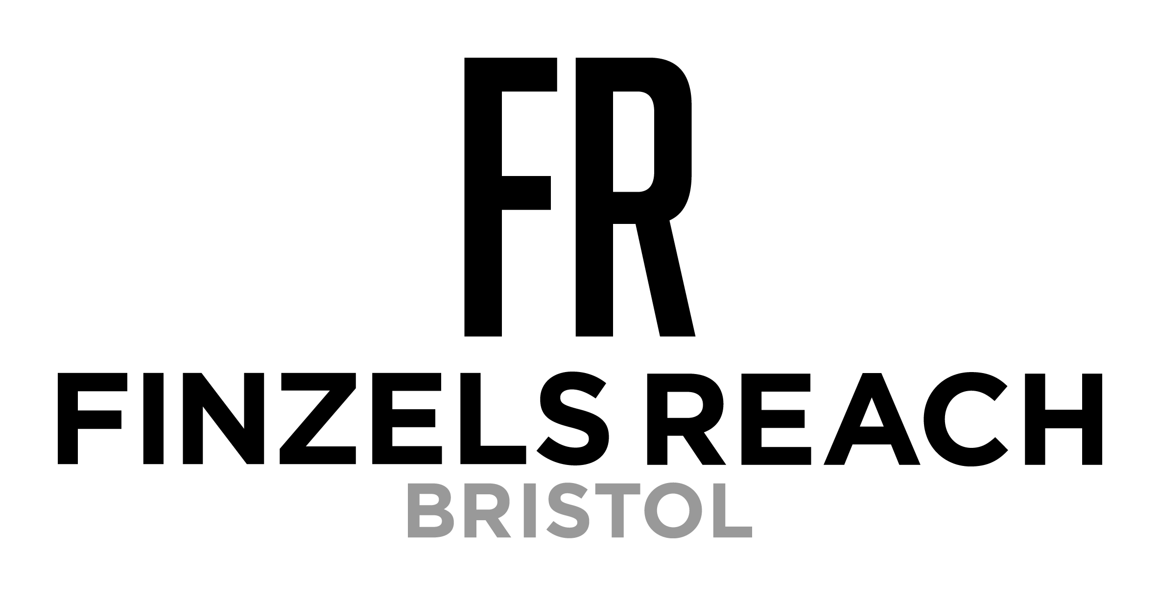

Finzels Reach Market to open twice weekly
during Coronavirus

Exciting news for Bristol foodies, Finzels Reach Market is adding an extra market day to the week! From 5th August, the market will be open on a Wednesday as well as a Friday!

Like most small businesses, Finzels Reach Market has had to adapt their market model in order to bring this popular weekly street food market back COVID-secure. Having reopened at the start of June with control measures in place and with less than half the usual stalls and new market layout; they have seen a great turnout from locals and foodies wanting to support these small and independent businesses.

Market director Sophie Bowden explained:

“We’ve been thrilled with the support we’ve received from the local community since we reopened. We’ve been able to operate the market on a smaller scale and regulate attendance accordingly. But as office workers start to return and knowing how busy the market can get; we want to make sure that we can continue to run the market safely. By opening the market twice a week means we’re able to manage our customer base over the 2 days as well as offering the usual amount of traders we had before the pandemic.“

Coronavirus has changed how we live and work and with news that offices are reopening slowly with groups of people working on different days; opening the market twice weekly will mean customers will have less of a chance of missing out on their weekly street food ritual.

Sophie added:

“We’re hopeful that in time we’ll be able to operate the market at full capacity but in the meantime, we’re delighted about having an additional market day. After all, who doesn’t want to eat street food twice a week?!”

The market will open twice weekly from Wednesday 5th August, 11am – 2pm.

Further details about the market and traders can be found on social media:

Facebook - FinzelsReachMarket
Twitter – @FinzelsReachMKT
Instagram – sophiebevents
Website – www.sophiebevents.co.uk

- Ends -

For further information about Finzels Reach Market, please contact Sophie Bowden at Sophie Bowden Events on 07961 326 187 or sophie@sophiebevents.co.uk

