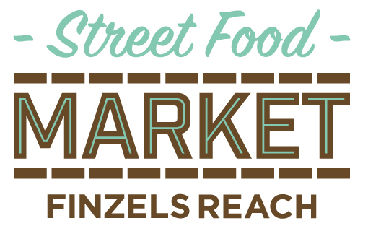
Last updated January 2019

Regular Traders

Ah Ma's Dumplings
Alp Mac
Chef de Maison
For Mice and Men
Jacobs Finest Falafel
The Kitchen Chef
Low 'n' Slow
Niangs Thai Snacks
She Sells Sushi

Alternative weeks

Mango Hub: Every 1st and 3rd Friday
Lovett Pies: Every 2nd and 4th Friday
Good Food & Co: Every 1st, 3rd and occasional 5th Friday
Murray Mays: Every 2nd and 4th Friday
Wood Chop Pizza: Every 2nd and 4th Friday
King Fin: Every 1st, 3rd and occasional 5th Friday
NYC Eats: Every 1st, 3rd and 5th Friday
Kebala Kitchen: Every 2nd Friday

